Super Id : 6401010

week-4 spring-rest-handson

Create a Spring Web Project using Maven

Here we will see the output on your local host

<http://localhost:8080/api/hello>

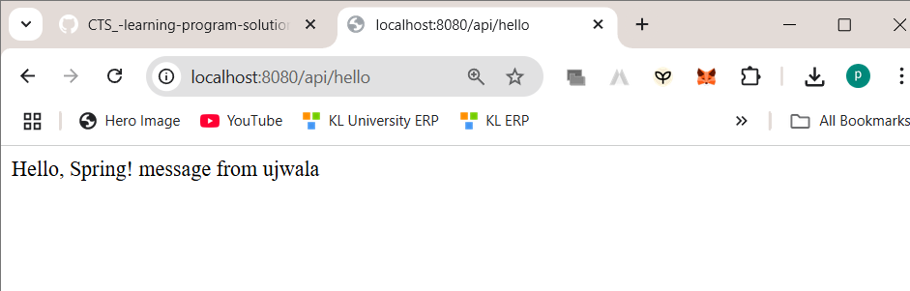

Helloacontroller.java

package com.cognizant.springlearn.controller;

import org.springframework.web.bind.annotation.*GetMapping*;

import org.springframework.web.bind.annotation.*RequestMapping*;

import org.springframework.web.bind.annotation.*RestController*;

@*RestController*

@*RequestMapping*("/api")

public class HelloController {

    @*GetMapping*("/hello")

    public String hello() {

        return "Hello, Spring! message from ujwala ";

    }

}

Application.properties

server.port=8080